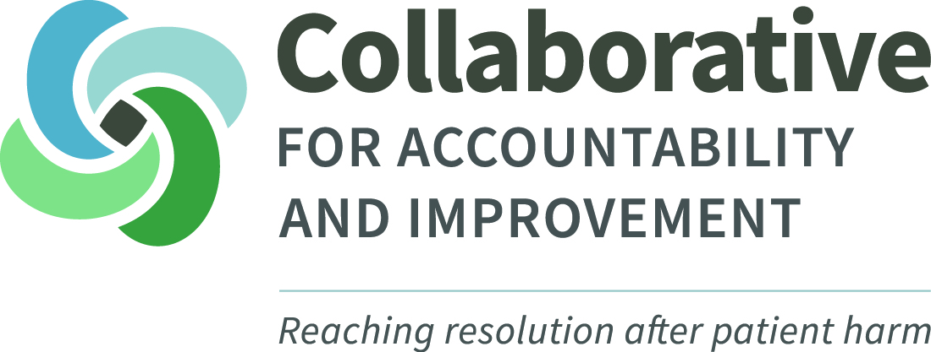

Northwest Communication and Resolution Program (CRP) Leader Retreat: Achieving Benefits, Avoiding Pitfalls
September 27 & 28, 2017
Marriott SeaTac Conference Center, SeaTac, Washington
Learn how your organization can implement an effective Communication and Resolution Program (CRP) at this retreat for healthcare leaders.
Despite our best efforts as care providers, adverse events happen far too often. Most efforts to respond to them don’t actively improve patient safety or meet the needs of patients and providers. CRPs turn adverse events into opportunities for improvement. They ensure open communication after an adverse event is discovered, a comprehensive analysis of what happened with subsequent safety improvements, emotional support for patients and providers, and an appropriate resolution. At this retreat, healthcare leaders will learn how to implement CRPs effectively in their organizations.

MEETING ATTENDEES: We plan to have 150 attendees from across the Northwest. Attendees will include hospital C-Suite/Board members, risk managers and patient safety staff, and clinicians.
SPONSORSHIP PACKAGES: The CRP Leader Retreat offers several levels from which to choose, based on your organization’s specific needs and communications strategies:
SPONSORSHIP RECOGNITION PACKAGE (Included with all levels)

- Logo placement, with prominence based on support level, on:
- Selected marketing materials (i.e., save-the-date announcements, registration announcements, reminder and follow up emails)
- Collaborative for Accountability and Improvement & Washington Patient Safety Collation websites
- Recognition from podium and in opening remarks
- Logo and organization description on posters displayed throughout event; length and prominence based on sponsor level
- Plus, the expanded benefits detailed below for each sponsor group…
PLATNIUM SPONSOR(S) $10,000 +

- Recognition as Platinum Sponsor in all promotional material:
  - Lead position on all key marketing materials
  - Lead logo position in all sponsor lists
  - Conference signage: Lead prominence for logo placement and organizational description
- Opportunity to provide welcoming remarks on Day 1 of Leader Retreat
- Opportunity to place promotional flyer/brochure in conference packets or giveaway item on tables during event
- Five (5) free registrations to the conference
- Designated table for general session(s), if desired
- Detailed attendee roster provided to sponsor prior to event date

GOLD SPONSOR(S) $7,500-9,999

- Recognition as Gold Sponsor in all promotional material:
  - Prominent position on all key marketing materials
  - Prominent logo placement in all sponsor lists
  - Conference signage- Prominent logo placement and organizational description
- Opportunity to provide welcoming remarks on Day 2 of Leader Retreat
- Four (4) free registrations to the conference
- Designated table for general session(s)/meal(s), if desired
- Detailed attendee roster provided to sponsor prior to event date

SILVER SPONSOR(S) $5,000-7,499

- Recognition as Silver Sponsor in all conference material:
  - Prominent logo placement in all sponsor lists
  - Conference signage logo and mention
- Introduction of speaker
- Three (3) free registrations to the conference
- Designated table for general session(s), if desired
- Detailed attendee roster provided to sponsor prior to event date

BRONZE SPONSOR(S) $2,500-4,999

- Recognition as Bronze Sponsor in all conference material:
  - Logo placement in all sponsor lists
  - Conference signage logo and mention
- Two (2) free registrations to the conference

SUPPORTER(S) OF CRPs $1,500-2,499

- Recognition as Supporter of Patient Safety in all conference material
- One (1) free registration to the conference

FRIENDS(S) OF CRPs $500-1,499

- Recognition as Friend of Patient Safety in all conference material

For more information, please contact:

Paulina Osinska
Manager, Collaborative for Accountability & Improvement
206.616.7220 | osinsp@uw.edu

2017 Conference
Sponsorships

Organization Information:

Note: Please complete this section with information as it should appear on promotional materials:

Full Organization Name: __________________________________________________
Organization/Product Website: _____________________________________________
Organization Address: ___________________________________________________
___________________________________________________
Organization Phone Number: ______________________________________________
Logo attached organization description attached Will send by: __________
Contact Information:

Contact Name: ________________________________________________________
Contact Title: __________________________________________________________
Contact Email: _________________________________________________________
Contact Phone Number: _________________________________________________
Sponsor Level:

Platinum Sponsor ($10,000+) Bronze Sponsor ($2,500-$4,999)
Gold Sponsor ($7,500-$9,999) Supporter of CRPs ($1,500-$2,499)
Silver Sponsor ($5,000-$7,499) Friend of CRPs ($500-$1,499)
Payment Options:
Check enclosed for $____________
We are sending a check for arrival by _____________________________
(Please make the check out to the University of Washington, for the CRP Leader Retreat Sponsorship)
** I understand that my organization must make a full or at least 50% payment in order to receive any of the benefits listed under these sponsorship packages. Initials: ______

Please return this form to:
Susan Worden
1959 NE Pacific Street
Seattle, WA 98195
Box 356526

